1. University Rank Holders

1. Akriti Aggarwal B.Tech. CSE 2019-23 Batch, secured 2nd Rank in university by scoring CGPA.
2. Xxxx
3. Xxxx
4. xxxx
5. Devanshi Chauhan B.Tech. ECE 2018-22 Batch, secured
6. Suvin Vargese of Masters in Business Administration, 2018-20 Batch, **Secured 2nd Rank**in university by scoring **8.79 CGPA**.
7. Harshit Singh Jadon of B.Tech., Electrical & Electronics Engineering, 2016-20 Batch, **secured 3rd Rank** in university by scoring **9.19 CGPA**.
8. Sarthak Tyagi of Information technology Branch, 2016-20 Batch, **Secured 2nd Rank**in university by scoring **9.07 CGPA**.
9. Sweta Malik of B.Tech., Information Technology, 2015-19 Batch, **Secured 3rd Rank**in university by scoring **86.42% Marks**.
10. Ankit Kumar Vardhan of B.Tech., Civil Engineering, 2015-19 Batch, **Secured 3rd Rank**in university by scoring **86.36% marks**.
11. Mohit Varshney of Masters in Business Administration, 2015-17 Batch, **Secured 5th Rank**in university by scoring **80.64% marks**.
12. Sunny Garg of B.Tech., Electrical & Electronics Engineering, 2012-16 Batch, **secured 2nd Rank**in university by scoring **85.78% marks**.

2. First Woman Officer in the Indian Navy

Our Alumnus **Kumudini Tyagi (B.Tech CSE-2017 Passout)** became one of the first Woman Officer in the Indian Navy to embark on warships as part of ship’s crew.

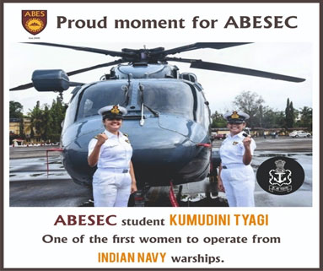

3. Projects with Aerosense Technologies Pvt. Ltd.

ABESEC has contributed to the development of a drone – HAWK EYE under Aerosense Technologies Pvt. Ltd. The successful trial was done in the presence of General Bipin Rawat,(Chief of Defence Services) in the difficult terrains of Ladakh region. The Hawk Eye Drone would be useful to carry essential commodities for the defence personnel to difficult terrains, even during rough weather conditions. The Drone has a capacity to carry fifty kilograms of essentials to an altitude of 1500 to 7000 meters. Soon this indigenous drone would be deployed and will be a part of the Indian Defence Forces.

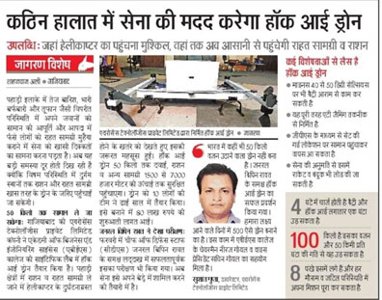

Another project of Aero Sense Technologies,’ Hawk Eye Drone Ambulance’, has been designed and is being processed at the Scientific Lab of ABES Engineering College. The Hawk Eye Drone Ambulance would be highly useful to ferry critical patients to hospitals in emergencies. The Hawk Eye Drone Ambulance would be able to carry 180 kilograms of weight and can fly for 10 kilometres at a speed of 150 kilometres per hour.

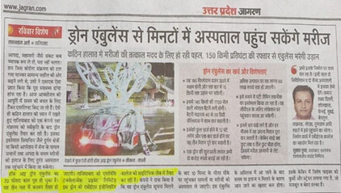

**(a). SAE EFFI CYCLE** - Our team secured an All India Rank of 28 from among 108 participating teams in 2016. SAE Effi Cycle is a National level student’s design competition organized annually by Society of Automotive Engineers – India. The participating teams are expected to design and manufacture a hybrid vehicle (human and battery powered) that can accommodate two passengers.

**(b). Electric-Solar Vehicle Championship (ESVC)**- Our team secured an all India 6th rank from among more than 100 participating teams and also bagged 5 non tournament prizes like Best Design and Best Business Plan awards in 2016 competition. ESVC is India’s biggest solar vehicle championship organized by Imperial Society of Innovative Engineers (ISIE).

**(c). ROBOCON 2016**- Our team secured an all India rank of 30, out of 67 participating teams. The National ABU Robocon 2016 took place in the Shri Shiv Chhatrapati Krida Sankul, Pune on 3–5 March 2016. The theme for Robocon 2016 was declared as 'Chai-Yo : Clean Energy Recharging the World.

**(d). UAV Challenge Medical Express Australia 2016**- Our team secured 11 Rank in the World, among 64 participating teams. The UAV Challenge Medical Express is an unmanned aircraft competition that demonstrates the use of robotic aircraft for medical sample retrieval and medical delivery.

**(e). India Innovation Challenge Design Contest 2016**- Two of our teams reached up to the quarter final stage of the competition. Out of 1300 participating teams only 428 teams reached up-to quarter-final stage. India Innovation Challenge Design Contest is a National level design and innovation contest organized by Texas Instruments in collaboration with Department of Science and Technology (DST).

4. Hackathon and Similar Events

* A team of 3rd year students including Mayankesh Mishra, Richa Srivastava, Ritika Malik, Aman Sharma and Ujjawal Sharma won first prize of Rs. 1,00,000/- in Smart India Hackathon 2020
* A team of 2nd year girls including Sanjana Jain, Astha Rai and Ishika Verma won third prize of 12,000/- in National Virtual Women Hackathon – 2020
* A team of 2nd year students including Shivani Rawat, Geetanjali Sharma, Shivam Motla and Shreyansh Sahai got the Gold Developer Certificate for making three simulators of Python Programming Virtual Lab in AKTU ebootathon4 – 2020
* A team of 3rd year students including Mayankesh Mishra, Richa Srivastava and Ritika Malik secured the First Prize of Value $449.99 in CISCO Hackathon
* Mayankesh Mishra and Ankit Tripathi secured the Winner position in Smart India Hackathon - 2020 (Software edition), MHRD, MIC, Govt. of India
* Our student Vishal Jain is Qualified & Certified as Ethical Hacker in CISCO, Ethical Hacker Examination
* Our student, Vishal Jain, is Certified as CyberOps Associate in CISCO
* Our student Umang Agrawal received the Special award on AKTU Foundation Day under ‘Talent Incentive Scheme’ in 2018-19

5. Cultural and Sports Fests

More than 250 students brought laurels to the institution by winning Gold, Silver and Bronze medals in cultural and sports fests organized by the University at Zonal and Regional Level.